

**RELIABLE BRAND MEDICAL BUSINESS OPC**

08 October 2024

To Whom It May Concern:

Greetings!

We write to formally introduce Reliable Brand Medical Business OPC, the official distributor of Brainlab and inomed medical equipment in the Philippines.

Inclusive are the following documents:

1. Company Profile
2. FDA- LTO
3. SEC- Certificate of Incorporation
4. Mayor’s/Business Permit
5. BIR Form 2303 (Certificate of Registration)
6. Letter of Authorization- Brainlab AG
7. Letter of Authorization- inomed Medizintechnik GmbH

If you have query/clarification or if you need assistance, you may contact the company at [info.rbmbopc@gmail.com](mailto:info.rbmbopc@gmail.com) or visit [www.reliableopc.com.](http://www.reliableopc.com/)

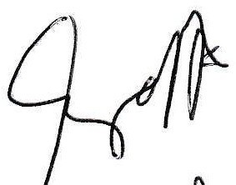Thank you. Very truly yours,

ENGR. MENELAO A. CALZADA

President, Reliable Brand Medical Business OPC

*For the Reliable Team*

Unit 301, 3F Eljay’s Building, Aguinaldo Highway, Anabu I-E, 4103 City of Imus, Cavite, Philippines (Main Office)

Units 12-14, Olivarez Condominium Bldg. 1, Juanita De Leon St., San Dionisio, 1700 Parañaque City, Metro Manila, Philippines (Satellite Office)

+63-46-416-6352 (Main Office) | +63-32-8470-8450 (Satellite Office) https://reliableopc.com | [info.rbmbopc@gmail.com](mailto:info.rbmbopc@gmail.com)